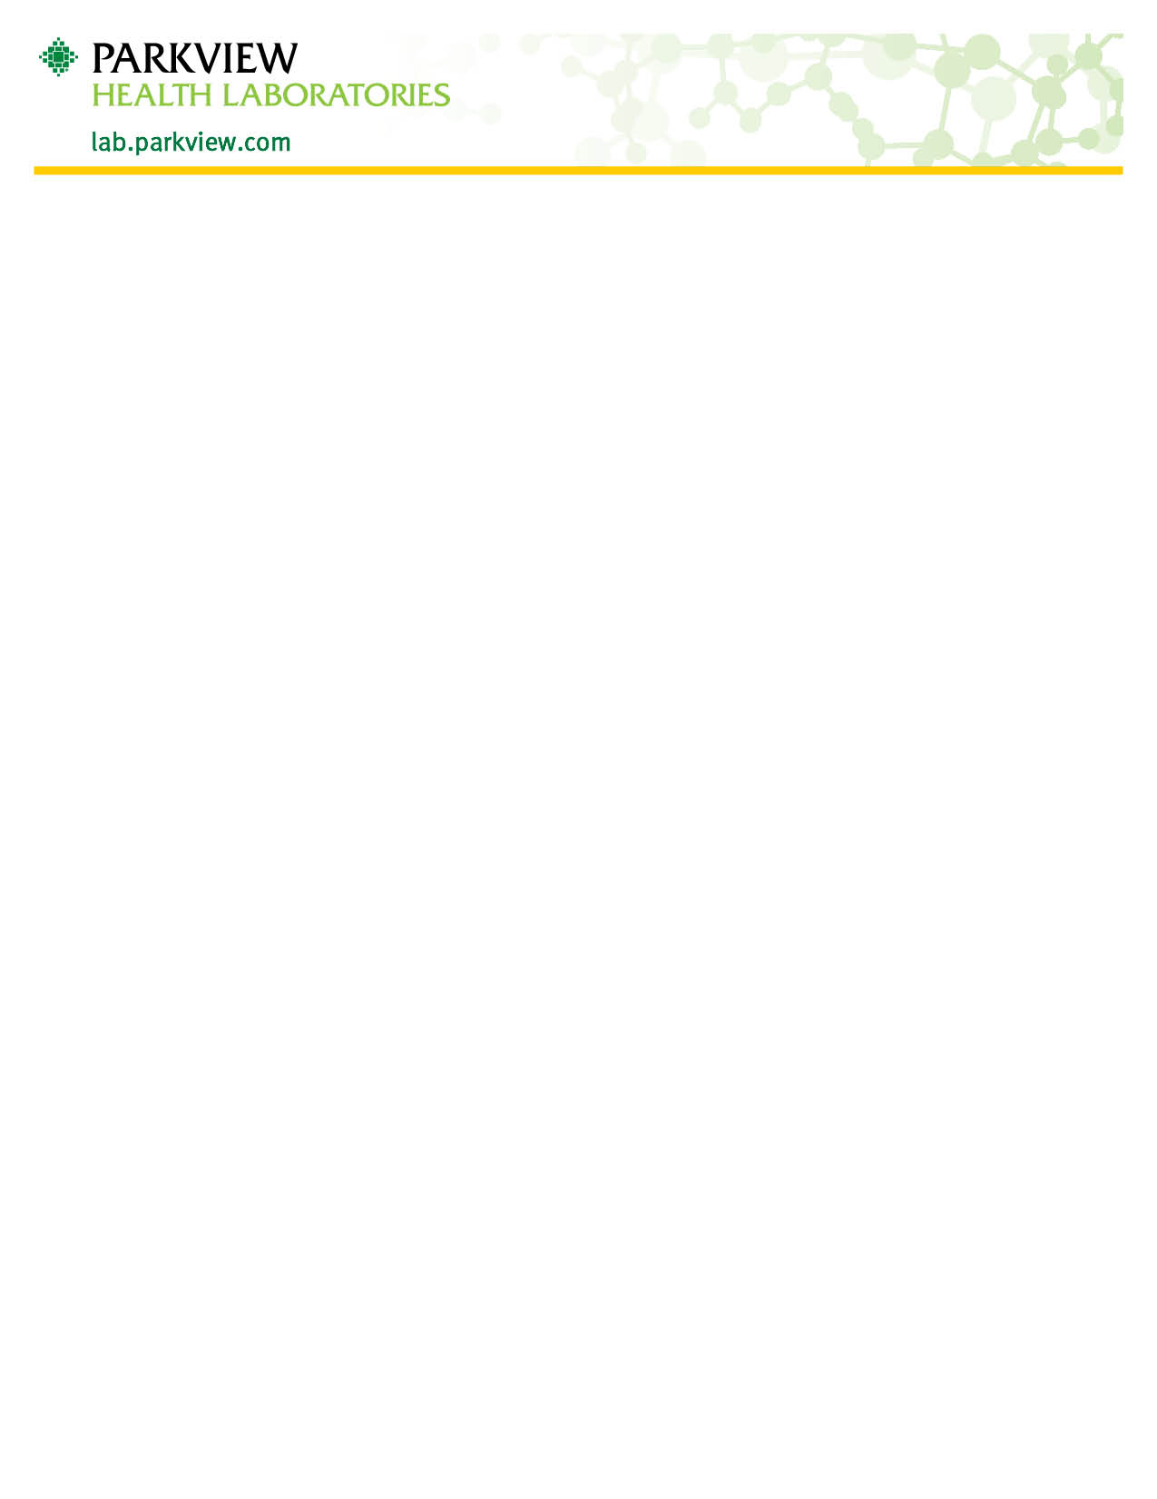

Clostridium difficile Toxin (C-diff) Collection
This test is for use with unformed stool samples only. Formed specimens will not be tested.
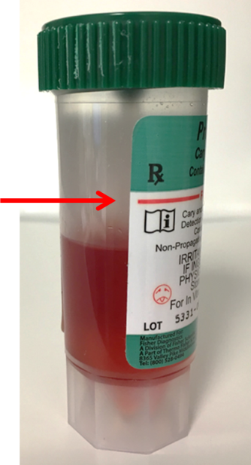
No more than 1 specimen per 7 days will be tested.
- Specimen should be collected in a clean, disposable container.
  - Stool may be collected from a diaper using plastic wrap to place inside diaper. The plastic wrap with the stool specimen should then be placed inside a clean disposable container.
- Add stool sample into the Green capped vial using the spork attached to the cap. Fill only to the red line on the vial.
- Wash hands after collection.
- Specimen should be labeled with full legal patient name, date of birth, date and time of collection.
- Specimen should be brought to the laboratory as soon as possible for testing.
- Specimen should be stored at refrigerated temperature and delivered within 5 days.

Any questions concerning collection for C. difficile can be directed to Parkview Health Laboratory at (260) 266-1500 Option 1.

